Morgan County Native and Invasive Plant Partnership

March 5th at 6pm
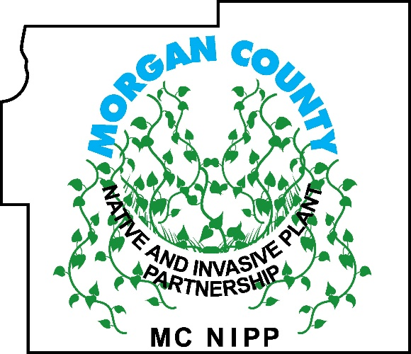
April 2nd at 6pm
May 7th at 6pm *
2024 MCNIPP MONTHLY MEETING DATES!
June 4th at 6pm
July 2nd at 6pm
August 6th at 6pm
September 3rd at 6pm *
October 1st at 6pm
November 5th at 5pm *
December 3rd at 6pm

Most meetings will be held at the Morgan County Admin Bldg. located at 180 South Main Street, Martinsville, IN 46151. *Those marked with asterisk will be wildflower hikes and will be held at the parks that we hold Weed Wrangles at.
For the location of the hikes, if you would like any information on MCNIPP or about invasive species, please contact us at invasivesmorgancounty@gmail.com or at 765-349-2060.

