On the other side of this paper is a map of a community that needs your help! Their waterways are being polluted with water from the community’s stormwater system and runoff from nearby farms. Best Management Practices are things that we can do tot help keep our waterways cleaner. Examples of the Best Management Practices (or BMPs) can be found in the middle of this page. Draw at least four Best Managements Practices (BMPs) where they will be best suited and explain how they will help filter or slow the water down before it reaches the stream. Think about what kind of pollutants may come from different areas. Remember to try and choose the correct BMP for that area but remember that more than one BMP may work for each pollutant!

Best Management Practices (BMPs)
Riparian Buffer
An area of trees and plants on either side of a waterway that reduces runoff and erosion caused by stormwater and barren soil.

Rain Garden
A garden that is planted in a depression and allows stormwater to be absorbed by plants and soil as it runs off of hard surfaces such as roofs, driveways, parking lots, and roads.

Eco or Green Roof
A roof that is partially or completely covered with plants and soil which help absorb precipitation (rainfall) and naturally insulate the building.

Pet and Animal Waste
Properly disposing of animal waste prevents the contamination of waterways with unwanted bacteria and nutrients

Cleaning up Litter
Keeping litter away from storm drains, creeks, and stream prevents it from traveling further down into a waterway

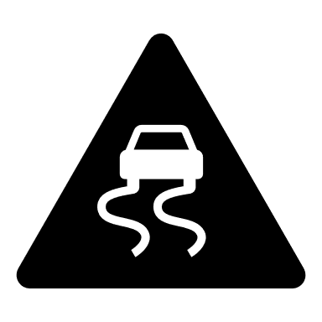
Porous Pavers and Concrete
Paving material that allows water to move through it and into the soil below increases the amount of water absorbed and decreases run off into storm drains.

Discussion:
1. What were some of the pollutants that you thought of and where did the originate or come from?
____________________________________________________________________________________________________________________________________________________________________________________________________
2. What BMPs did you choose to use and why?
____________________________________________________________________________________________________________________________________________________________________________________________________
3. Which BMP do you think would be the easiest to do? Which might cost the most money?
____________________________________________________________________________________________________________________________________________________________________________________________________

